SCREENSHOT
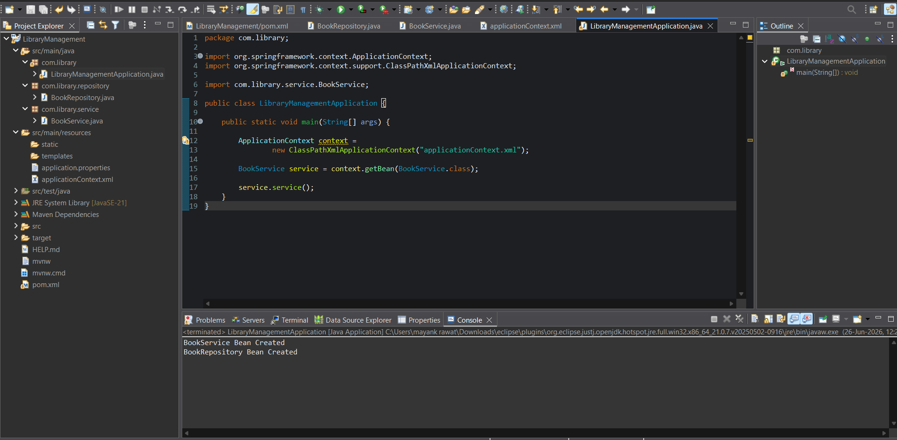

LibraryManagementApplication.java
package com.library;

import org.springframework.context.ApplicationContext;
import org.springframework.context.support.ClassPathXmlApplicationContext;
import com.library.service.BookService;

public class LibraryManagementApplication {
public static void main(String[] args) {
ApplicationContext context = new ClassPathXmlApplicationContext("applicationContext.xml");
BookService service = context.getBean(BookService.class);
service.service();
}
}

BookRepository.java
package com.library.repository;

public class BookRepository {
public void display() {
System.out.println("BookRepository Bean Created");
}
}

BookService.java
package com.library.service;

import com.library.repository.BookRepository;

public class BookService {
private BookRepository bookRepository;

// Setter Injection
public void setBookRepository(BookRepository bookRepository) {
this.bookRepository = bookRepository;
}

public void service() {
System.out.println("BookService Bean Created");
bookRepository.display();
}
}

applicationContext.xml
<?xml version="1.0" encoding="UTF-8"?>
<beans xmlns="http://www.springframework.org/schema/beans"
xmlns:xsi="http://www.w3.org/2001/XMLSchema-instance"
xsi:schemaLocation="http://www.springframework.org/schema/beans
https://www.springframework.org/schema/beans/spring-beans.xsd">

<bean id="bookRepository" class="com.library.repository.BookRepository"/>

<bean id="bookService" class="com.library.service.BookService">
<property name="bookRepository" ref="bookRepository"/>
</bean>
</beans>

Pom.xml
<?xml version="1.0" encoding="UTF-8"?>
<project xmlns="http://maven.apache.org/POM/4.0.0"
xsi:schemaLocation="http://maven.apache.org/POM/4.0.0 https://maven.apache.org/xsd/maven-4.0.0.xsd"
xmlns:xsi="http://www.w3.org/2001/XMLSchema-instance">
<modelVersion>4.0.0</modelVersion>
<groupId>org.springframework</groupId>
<artifactId>spring-context</artifactId>
<version>6.1.8</version>
<name>Spring Context</name>
<dependencies>
<dependency>
<groupId>org.springframework</groupId>
<artifactId>spring-beans</artifactId>
<version>6.1.8</version>
</dependency>
</dependencies>
</project>


